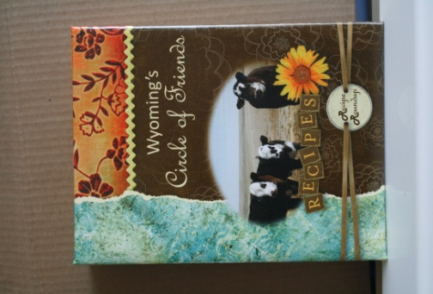

***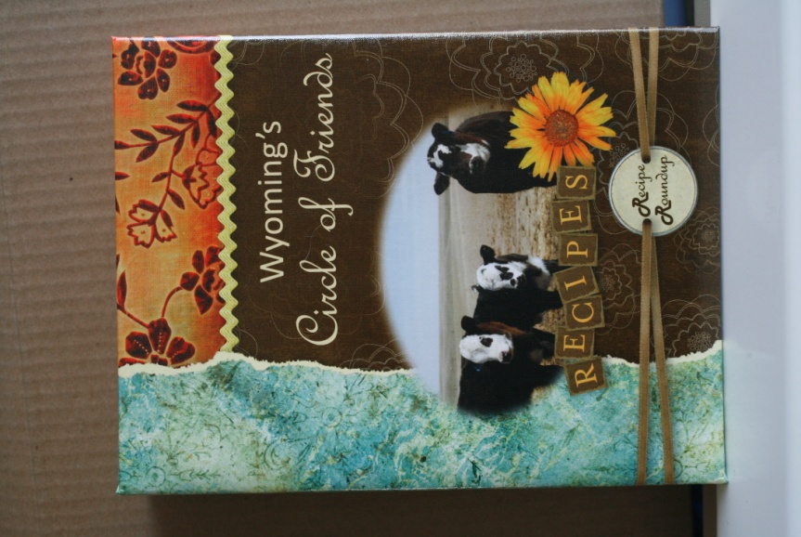***

***THE WYOMING***

***“CIRCLE OF FRIENDS” COOKBOOK***

This FABULOUS cookbook is filled with over

400 recipes from the best cooks ever--

Eastern Star members and friends!

This beautiful 3-ring, hard cover cookbook is a one-of-a-kind collection of recipes that you will find delicious and delightful! The inside of the cover as well as each section divider, is printed with useful cooking tips. The section divider photographs have been taken in Wyoming. Best of all, there are many, many favorite recipes from really good cooks! Any cook would be thrilled to receive this cookbook as a gift.

C:\Documents and Settings\Compaq_Owner\Local Settings\Temporary Internet Files\Content.IE5\QZM2OR02\MC900296125[1].wmf

Cookbooks: **$20.00 each; delivered (if possible to an OES function)**

**$24.00 each; boxed and mailed**

C:\Documents and Settings\Compaq_Owner\Local Settings\Temporary Internet Files\Content.IE5\K5LJ3BSN\MC900129382[1].wmfTo order, please print and complete the following form, and mail with your check or money order to: **WY Circle of Friends, P.O. Box 2362, Cheyenne, WY 82003**. Please make checks payable to: WY *Circle of Friends*.

-------------------------------------------------------------------------------------------------------

Please send \_\_\_\_\_\_ copies to:

Name:\_\_\_\_\_\_\_\_\_\_\_\_\_\_\_\_\_\_\_\_\_\_\_\_\_\_\_\_\_\_\_\_\_\_\_\_\_\_\_\_\_\_\_\_\_\_\_\_\_

Address:\_\_\_\_\_\_\_\_\_\_\_\_\_\_\_\_\_\_\_\_\_\_\_\_\_\_\_\_\_\_\_\_\_\_\_\_\_\_\_\_\_\_\_\_\_\_\_

City:\_\_\_\_\_\_\_\_\_\_\_\_\_\_\_\_\_\_\_State:\_\_\_\_\_\_\_Zip:\_\_\_\_\_\_\_\_\_\_\_\_\_\_\_\_

Phone:\_\_\_\_\_\_\_\_\_\_\_\_\_\_\_\_

e-mail address:\_\_\_\_\_\_\_\_\_\_\_\_\_\_\_\_\_\_\_\_\_\_\_\_\_\_\_\_\_\_\_\_\_

If desired, you may place your order via e-mail (see prices above). Please submit order information with your address and number of cookbooks wanted, followed by your payment to WY Circle of Friends, P.O. Box 2362, Cheyenne, WY 82003. e-mail address: [mas54418@gmail.com](mailto:mas54418@gmail.com).

*(All proceeds benefit Wyoming’s 2018-2021 Triennial Fund)*